|  |  |
| --- | --- |
| A picture of a winding road and trees  Steel  Restaurant | Jesse Stokes  Fall 2017  Information Technology |

Contents

Key 2

Site Specification 3

Rational/Focus 3

Measurement of success 3

Main Element Outline 4

Common Elements to every page 4

Individual Page Elements for each page 4

Target Audience Analysis 6

Hierarchy Chart Storyboard 7

Visual Diagrams 8

Templates 8

Site Standards 10

Font Specifications 10

Graphics Specifications 10

Naming Conventions 14

Industry Standard 14

Development standard: 14

Steel “index.html” 14

Test Plan 15

Maintenance Plan: 16

External CSS 17

Key:

Site Map: Every Page (index.html)

External CSS: Every Page (stylelayer1.css, stylelayer2.css, stylelayer3.css)

Float Property: Every Page (index.html)

Forms: Events Pages (st_ev_re.html, st_ev_ca.html, st_ev_ba.html)

Table: Menu Pages (st_me_br.html, st_me_lu.html, st_me_di.html)

Ordered List: Membership Page (st_sp_me.html)

Unordered List: Happy Hour page, Nav (st_sp_ha.html, index.html)

Description List: Restaurant Story (st_ab_re.html)

3 External Links: Find Us page (st_fi.html) map link for directions

Seafood Origins (st_fo_se.html) link in content to fish market website

Produce Origins (st_fo_pr.html) link in content to farm website

Meat Origins (st_fo_me.html) link in content to farm website

Link to Email Address: Find Us page (st_fi.html) email us link on left

ID Attribute (back to top): Events Pages (st_ev_re.html, st_ev_ca.html, st_ev_ba.html) in form

Graphics: Every Page (index.html)

Site Specification:

Rational/Focus:

* The focus of the site is to increase visibility for the restaurant as well as control restaurant traffic through reservations.

Measurement of success:

* Success will be measured through a increasing restaurant profits, and a year over year 10% growth in revenue would be considered a success, the measurement to measure success regarding restaurant traffic will be measured with a client experience survey and a measurement of 8/10 would be considered a success.
* Aside from measurable goals a main priority will be having a website that is user friendly to a wide demographic of people and insuring anyone who wants to visit our website can understand what kind of business we are at the core.

Main Element Outline:

The layout of the website coincides with my hierarchy chart where there is one main webpage that contains links to six categories, each of these categories will contain navigation links to sub-categories and home, each of the sub-categories will also contain navigation links of their parent category and home.

## Common Elements to every page

* Main logo
* Header (title of current page visiting)
* Navigation bar (About Us, Food Origins, Menus, Specials, Events, Find Us or Main Page)
* Footer (back to top, copyright information)

# Individual Page Elements for each page

* Steel main page (index.html)

This will be the landing page of the site and the navigation bar will link to six main categories “About Us, Food Origins, Menus, Specials, Events, Find Us”

* + About Us (st_ab.html)

This page will contain body information and a navigation bar containing these four categories “Home, Our Mission, Restaurant Story, Gallery”

* + - Our Mission (st_ab_ou.html)
    - Restaurant Story (st_ab_re.html)
    - Awards (st_ab_aw.html)
  + Food Origins (st_fo.html)

This page will contain body information and a navigation bar containing these four categories “Home, Seafood Origins, Produce Origins, Meat Origins”

* Seafood Origins (st_fo_se.html)
  + - Produce Origins (st_fo_pr.html)
    - Meat Origins (st_fo_me.html)
  + Menus (st_me.html)

This page will contain body information and a navigation bar containing these four categories “Home, Brunch, Lunch, Dinner”

* + - Brunch (st_me_br.html)
    - Lunch (st_me_lu.html)
    - Dinner (st_me_di.html)
  + Specials (st_sp.html)

This page will contain body information and a navigation bar containing these three categories “Home, Happy Hour, Memberships”

* + - Happy Hour (st_sp_ha.html)
    - Memberships (st_sp_me.html)
  + Events (st_ev.html)

This page will contain body information and a navigation bar containing these three categories “Reservations, Catering, Banquet Room”

* + - Reservations (st_ev_re.html)
    - Catering (st_ev_ca.html)
    - Banquet Room (st_ev_br.html)
  + Find Us (st_fi.html)

This page will contain body information and links for customers to contact us.

Target Audience Analysis:

Below are the list of qualities I anticipate visiting my web site

* Primarily ages between 25-70
* I believe the site visits will be equal between men and women
* I expect the education to range from relatively uneducated to well-educated college graduates
* I believe the lowest common denominator for reading and vocabulary to be at least an 8th grade level
* I think a good number of customers will have a low technical level
* I expect my website will be accessed with old and new operating systems alike
* I expect the common mainstream browsers to be used (Chrome, Firefox, Internet Explorer, Safari)
* I feel connection speeds will be a mix of low speed and high speed
* I expect people trying to access a restaurant website to have a range of resolutions from 4k down to sub HD (1900x600)

Hierarchy Chart Storyboard:

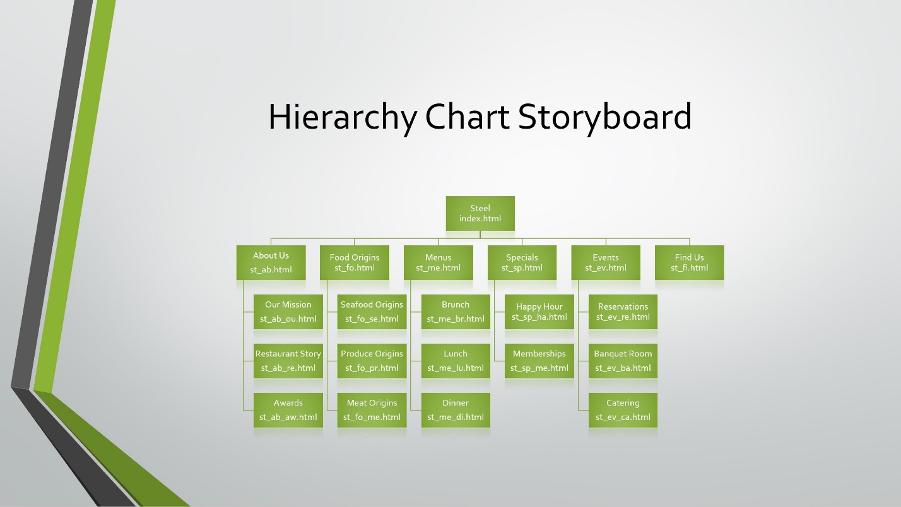

Visual Diagrams:

Templates:

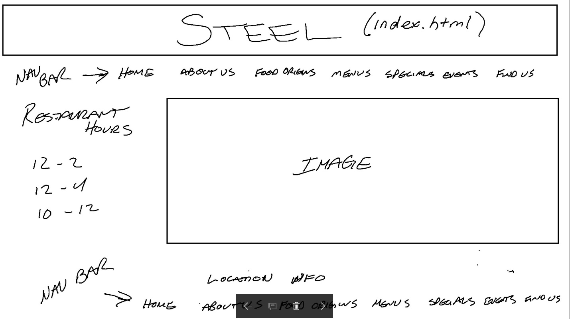

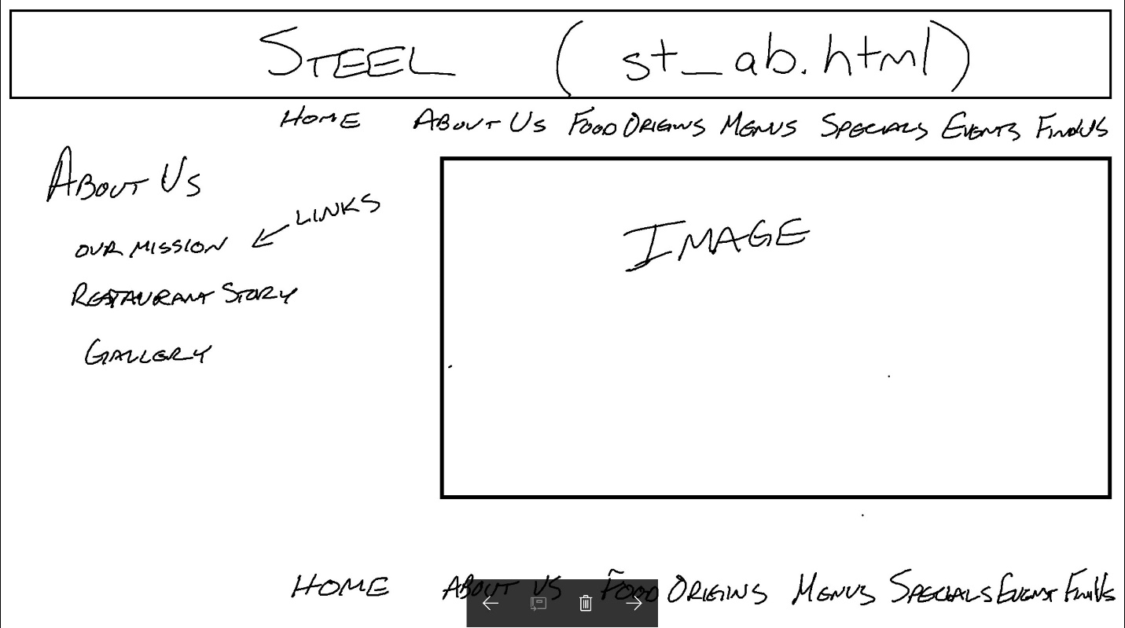

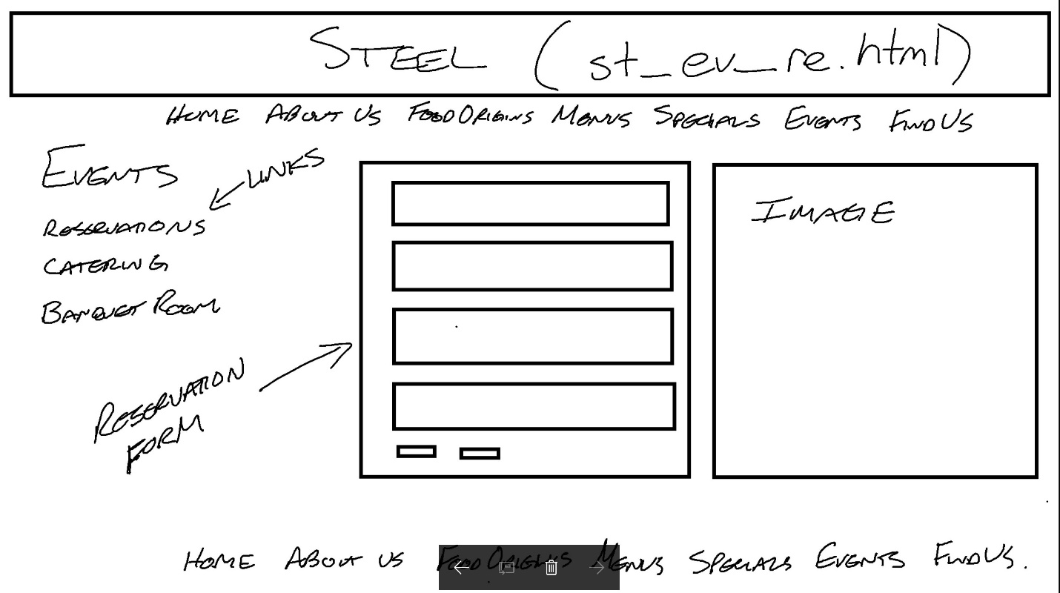

Site Standards:

Font Specifications:

Font Family - Arial, Helvetica, sans-serif fonts will be used uniformly throughout the website, this includes all headings and paragraph text.

Font Size - will be 1.1em for all body text and elements. The (h1-h6) headings used in the site will be the default point size as I do not plan to customize the (h1-h6) elements.

Graphics Specifications:

All Images are open source from: <https://www.pexels.com/>

Color - The colors used for text on the website will be “Gray” text in top of a “Black” background and will be uniform across the website. The exception will be the (h1) heading element on top of each page and the active navigation bars will be the reverse with a “Gray” background and “Black” text.

Class names:

* “container”
* “seafood”
* “protein”
* “produce”
* “membership”
* “happy”
* “message”
* “about”
* “king”
* “formcontainer”
* “main”

I have included the following rules for elements on my website:

* {

margin: 0;

padding: 0;

}

body {

font-size: 1.1em;

font-family: Arial, Helvetica, sans-serif;

background-color: black;

}

#container {

width: 90%;

margin: 10px auto;

border: 2px solid black;

border-radius: 22px;

background-color: gray;

}

header {

padding: 2%;

letter-spacing: 2em;

background-color: gray;

text-align: center;

text-transform: uppercase;

}

nav {

padding: 2%;

background-color: black;

text-align: center;

}

nav ul li {

display: inline;

list-style-type: none;

}

nav a {

padding: 0.25em;

color: gray;

font-weight: bold;

text-decoration: none;

}

nav a:hover {

color: black;

background-color: gray;

}

aside {

float:left;

padding: 0 0.7%;

color: gray;

background-color: black;

text-align: center;

}

aside p a {

color: gray;

text-decoration: none;

}

#main {

float: right;

background-color: black;

}

footer {

clear: both;

color: gray;

background-color: black;

text-align: center;

}

footer p a {

text-decoration: none;

font-weight: bold;

}

footer a {

color: gray;

}

footer p a:hover {

color: black;

background-color: gray;

}

Naming Conventions:

Industry Standard

“IOS lion”- This website will be built following the mac naming convention for all OSX operating systems prior to lion. Which means up to 31 characters and only the underscore are allowed in naming files. (no spaces allowed between words).

Development standard:

I am naming my files following mac naming conventions to allow for compliance with previous generation operating systems. I am using a breadcrumb method. Each webpage will contain the first two letters of the title of the webpage with an underscore separating the each additional page. I have included an example below of my hierarchy chart in text for with the webpage file name in quotes.

Steel “index.html”

* About Us “st_ab.html”
  + Our Mission “st_ab_ou.html”
  + Restaurant Story “st_ab_re.html”
  + Awards “st_ab_aw.html”
* Food Origins “st_fo.html”
  + Seafood Origins “st_fo_se.html”
  + Produce Origins “st_fo_pr.html”
  + Meat Origins “st_fo_me.html”
* Menus “st_me.html”
  + Brunch “st_me_br.html”
  + Lunch “st_me_lu.html”
  + Dinner “st_me_di.html”

* Specials “st_sp.htm”
  + Happy Hour “st_sp_ha.htm”
  + Memberships “st_sp_me.html”
* Events “st_ev.html”
  + Reservations “st_ev_re.html”
  + Catering “st_ev_ca.html”
  + Banquet Room “st_ev_ba.html”
* Find Us “st_fi.html”

Test Plan:

Below serves as an outline of how I will be testing my website:

* Browsers I am using for testing
  + Firefox – Version: 54.0.1
  + Internet Explorer – Version: 11
  + Chrome – Version: 60.0.3112
  + Safari – Version: 5.1.7
* Connection Speeds will be tested throughout development and upon completion of the website.
  + Home testing speed using “www.speakeasy.net”
    - Download (66.5 Mbps)
    - Upload (5.9 Mbps)
* Screen Resolutions will be tested throughout development and upon completion of the website.
  + 3840x2160
  + 1920x1080
  + 1600x900
* Operating System
  + Windows 10 Home
* Page Validation

Page validation will be completed throughout development at the completion of each webpage and each individual page will additionally be validated upon completion of the website. I will use the following services for validation.

* + W3C Markup Validation Service
  + W3C CSS Validation Service

Maintenance Plan:

* The schedule for updating and maintaining the website will occur at the beginning of each month or as needed.
* The approval process for adding new pages, graphics or any other changes will need to be approved by the webmaster before implementation.
* Ongoing testing to ensure proper function of the website will occur at the beginning of each month and will include testing of the following:
  + Links
  + Graphics and photos
  + Forms

External CSS:

I have 3 different external style sheets that represent 3 different layers of my website. I have included a description of all web pages and the corresponding style sheets. Below the descriptions I have pasted all 3 actual style sheets.

* index.html stylelayer1.css
* st_ab.html stylelayer2.css

st_fo.html stylelayer2.css

st_me.html stylelayer2.css

st_sp.html stylelayer2.css

st_ev.html stylelayer2.css

st_fi.html stylelayer2.css

* st_ab_ou.html stylelayer3.css

st_ab_re.html stylelayer3.css

st_ab_aw.html stylelayer3.css

st_fo_se.html stylelayer3.css

st_fo_pr.html stylelayer3.css

st_fo_me.html stylelayer3.css

st_me_br.html stylelayer3.css

st_me_lu.html stylelayer3.css

st_me_di.html stylelayer3.css

st_sp_ha.html stylelayer3.css

st_sp_me.html stylelayer3.css

st_ev_re.html stylelayer3.css

st_ev_ba.html stylelayer3.css

st_ev_ca.html stylelayer3.css

# stylelayer1.css

/* style layer 1 rules */

/* Author: Jesse Stokes */

/* Date: 9.17.2017 */

* {

margin: 0;

padding: 0;

}

body {

font-size: 1.1em;

font-family: Arial, Helvetica, sans-serif;

background-color: black;

}

#container {

width: 90%;

margin: 0 auto;

background-color: gray;

}

header {

padding: 2%;

letter-spacing: 2em;

background-color: gray;

text-align: center;

text-transform: uppercase;

}

nav {

padding: 2%;

background-color: black;

text-align: center;

}

nav ul li {

display: inline;

list-style-type: none;

}

nav a {

padding: 0.25em;

color: white;

font-weight: bold;

text-decoration: none;

}

nav a:hover {

color: black;

background-color: white;

}

aside {

float:left;

padding: 40px;

color: gray;

background-color: black;

text-align: center;

margin-top: 50px;

}

aside h2 {

color: white;

}

aside p a {

color: gray;

text-decoration: none;

}

#main {

float: right;

background-color: black;

}

footer {

clear: both;

color: gray;

background-color: black;

text-align: center;

}

footer p a {

text-decoration: none;

font-weight: bold;

color: white;

}

footer a {

color: gray;

}

footer p a:hover {

color: black;

background-color: white;

}

# stylelayer2.css

/* style layer 2 rules */

/* Author: Jesse Stokes */

/* Date: 9.17.2017 */

* {

margin: 0;

padding: 0;

}

body {

font-size: 1.1em;

font-family: Arial, Helvetica, sans-serif;

background-color: black;

}

#container {

width: 90%;

margin: 0 auto;

background-color: gray;

}

header {

padding: 2%;

letter-spacing: 2em;

background-color: gray;

text-align: center;

text-transform: uppercase;

}

nav {

padding: 2%;

background-color: black;

text-align: center;

}

nav ul li {

display: inline;

list-style-type: none;

}

nav a {

padding: 0.25em;

color: white;

font-weight: bold;

text-decoration: none;

}

nav a:hover {

color: black;

background-color: white;

}

aside {

float:left;

padding: 40px;

color: gray;

background-color: black;

text-align: center;

margin-top: 50px;

}

aside h2 {

color: white;

}

aside p a {

color: gray;

text-decoration: none;

}

aside p a:hover {

color: black;

background-color: white;

}

form {

margin: 1em;

border: solid 2px gray;

padding: 2em;

font-size: 16px;

color: gray;

}

#formcontainer {

width: 47%;

color: gray;

display: block;

padding: 20px;

float: left;

}

#message {

margin: 5px;

}

fieldset {

margin: 0 0 0 0px;

}

label {

padding: 5px;

}

#main {

float: right;

background-color: black;

}

input {

margin: 5px;

}

input.button {

color: black;

text-transform: uppercase;

font-weight: bold;

padding: 4px;

background-color: gray;

display: inline;

}

footer {

clear: both;

color: gray;

background-color: black;

text-align: center;

}

footer p a {

text-decoration: none;

font-weight: bold;

color: white;

}

footer a {

color: gray;

}

footer p a:hover {

color: black;

background-color: white;

}

# stylelayer3.css

/* style layer 3 rules */

/* Author: Jesse Stokes */

/* Date: 9.17.2017 */

* {

margin: 0;

padding: 0;

}

body {

font-size: 1.1em;

font-family: Arial, Helvetica, sans-serif;

background-color: black;

}

#container {

width: 90%;

margin: 0 auto;

background-color: gray;

}

header {

padding: 2%;

background-color: gray;

letter-spacing: 2em;

text-align: center;

text-transform: uppercase;

}

nav {

padding: 2%;

background-color: black;

text-align: center;

}

nav ul li {

display: inline;

list-style-type: none;

}

nav a {

padding: 0.25em;

color: white;

font-weight: bold;

text-decoration: none;

}

nav a:hover {

color: black;

background-color: white;

}

aside {

float:left;

padding: 40px;

color: gray;

background-color: black;

text-align: center;

margin-top: 50px;

}

aside h2 {

color: white;

}

aside p a {

color: gray;

text-decoration: none;

}

aside a:hover {

color:black;

background-color: white;

}

#seafood {

color: gray;

padding: 50px;

margin: 10px 20px 20px 10px;

}

#seafood a {

color: white;

}

#seafood a:hover {

color: black;

background-color: white;

}

#protein {

color: gray;

padding: 50px;

margin: 10px 20px 20px 10px;

}

#protein a {

color: white;

}

#protein a:hover {

color: black;

background-color: white;

}

#produce {

color: gray;

padding: 50px;

margin: 10px 20px 20px 10px;

}

#produce a {

color: white;

}

#produce a:hover {

color: black;

background-color: white;

}

#membership {

color: gray;

padding: 50px;

margin: 20px 150px;

float: right;

}

#happy {

color: gray;

padding: 50px;

margin:20px 300px;

float: right;

}

#happy li {

padding: 10px;

margin: 0 0 20px 20px;

}

#message {

margin-left: 5px;

}

#about {

color: gray;

padding: 20px;

margin: 10px 20px 20px 10px;

}

#king {

color: gray;

padding: 20px;

margin: 10px 20px 20px 10px;

}

ol li {

margin:25px;

}

dl {

margin: 25px;

}

dl dt,dd {

padding: 5px;

}

table {

color: white;

border: double thin gray;

padding: 40px;

float: right;

margin: 10px 150px 30px 75px;

text-align: center;

}

caption {

padding: 4px;

font-weight: bold;

}

th {

padding: 10px;

}

td {

padding: 3px;

color: gray;

}

form {

margin: 1em;

border: solid 2px gray;

padding: 2em;

font-size: 16px;

color: gray;

}

form a {

color: white;

text-decoration: none;

}

form a:hover {

color: black;

background-color: white;

}

#formcontainer {

width: 47%;

float: right;

margin: 0 0 0 20px;

}

.labelfloatleft label {

width: 100px;

margin-right: 15px;

color: gray;

float: left;

text-align: right;

}

.labelfloatleft input {

display: block;

}

fieldset {

color: gray;

display: block

}

fieldset.group {

float: none;

border: 0;

margin: 0;

padding: 0;

}

fieldset label {

padding: 5px;

}

input {

margin: 5px;

}

input.button {

color: black;

text-transform: uppercase;

font-weight: bold;

padding: 4px;

background-color: gray;

display: inline;

}

legend {

color: white;

padding: 10px;

}

textarea {

margin: 10px;

}

#main {

background-color: black;

float: left;

margin:10px;

}

footer {

clear: both;

color: gray;

background-color: black;

text-align: center;

padding: 5px;

}

footer p a {

text-decoration: none;

font-weight: bold;

color: white;

padding: 5px;

}

footer a {

color: gray;

}

footer p a:hover {

color: black;

background-color: white;

}